Practical 09 – Final Task

Aim
Implement a Personalized Dashboard that uses both localStorage and sessionStorage to remember user settings and temporary state.

Scenario
You are creating a “Personal Dashboard” that remembers a user’s:
- Name (persistent)
- Theme (light/dark)
- Font size (small/medium/large)
- Temporary visit count (session-only)
- Feedback message draft (session-only)
However, the following starter code was written by a developer intern who made several mistakes and inconsistencies. Your job is to debug and complete the project without rewriting everything — only fix where necessary.

Starter Code (with random issues and misleading hints)
<!DOCTYPE html>
<html lang="en">
<head>
<meta charset="UTF-8">
<title>Personal Dashboard</title>
<style>
body {
font-family: Verdana, sans-serif;
transition: all 0.4s ease;
text-align: center;
padding: 20px;
}
.dark { background-color: #121212; color: white; }
.light { background-color: #ffffff; color: black; }
#controls button, select {
margin: 6px;
padding: 8px 14px;
border: none;
border-radius: 5px;
cursor: pointer;
}
</style>
</head>
<body>
<h1 id="welcomeText">Welcome!</h1>

<div id="controls">
<input type="text" id="userName" placeholder="Enter your name">
<button id="saveUser">Save Name</button>
<button id="themeBtn">Switch Theme</button>
<select id="fontChooser">
<option value="small">Small</option>
<option value="medium">Medium</option>
<option value="large">Large</option>
</select>
</div>

<p id="tabCounter"></p>

<h3>Feedback</h3>
<textarea id="feedback" rows="5" cols="40" placeholder="Your feedback..."></textarea>

<script>
// --- Theme Setup (??)
let themeNow = localStorage.getItem("ThemeMode");
if (themeNow == undefined) {
themeNow = "Dark"; // default?
}
document.body.classList.add(themeNow.toLowerCase());

document.getElementById("themeBtn").onclick = function() {
// The intern thinks this toggles theme correctly...
let t = document.body.classList.contains("light") ? "dark" : "light";
document.body.classList = t;
localStorage.setItem("theme", t); // same key used elsewhere?
};

// --- Font size (has one wrong reference)
const fSelect = document.getElementById("fontChooser");
fSelect.onchange = function() {
let f = fSelect.value;
document.body.style.fontSize = f;
localStorage.setItem("fontsizePref", f);
};
let storedFont = localStorage.getItem("fontSizePref"); // note the capital S :)
if (storedFont) {
document.body.style.fontSize = storedFont;
fSelect.value = storedFont;
}

// --- Username (one line incorrect)
document.getElementById("saveUser").onclick = function() {
let user = document.getElementById("userName").value;
localStorage.name = user; // hmm...
document.getElementById("welcomeText").innerText = "Welcome, " + localStorage.getItem("username");
};
// should also auto-show saved user, but missing logic

// --- Session Counter (needs debugging)
let count = sessionStorage.getItem("visits") ?? 1;
sessionStorage.setItem("visits", count++);
document.getElementById("tabCounter").innerHTML =
`This tab has been refreshed ${count} times.`;

// --- Feedback (autosave works, restore missing)
const fb = document.getElementById("feedback");
fb.addEventListener("keyup", () => {
sessionStorage.setItem("feedbackText", fb.innerHTML);
});
</script>
</body>
</html>

Task 1 – Fix Theme Storage
- There are two different key names used for theme in localStorage (ThemeMode and theme).
- Identify which one to keep and make the logic consistent.
- Ensure the theme defaults to light, not dark.
- The theme must persist across reloads.
Hint: classList assignment line is wrong — look at .classList = t;.

Task 2 – Repair Font Size Logic
- The dropdown saves font size but fails to load properly.
- The bug involves capitalization in the storage key and possibly the unit (“small” ≠ “smallpx”).
- Font size should visually change and persist.
Hint: compare "fontsizePref" vs "fontSizePref" carefully.

Task 3 – Username Greeting
- The intern mixed localStorage.name with localStorage.getItem("username").
- Fix it so it saves and retrieves properly.
- Show the username automatically on reload.
Hint: use one consistent key, not both.

Task 4 – Session Counter
- The logic with count++ and the placement of setItem is wrong.
- Fix it so each reload increases the counter by 1.
- Reset only when the tab is closed.
Hint: increment after converting the value to a number.

Task 5 – Feedback Restoration
- The app stores feedback incorrectly (innerHTML instead of value).
- Add the missing “load saved feedback” logic on startup.
- Verify that feedback persists only within the same tab.
Hint: textarea.value not innerHTML.

Final Task
Add a “Reset Preferences” button that:
- Clears all persistent storage (but not session storage).
- Reloads the page.

What You Should Observe
Feature | Storage Type | Persists After Reload? | Persists After Closing Tab?
Theme | localStorage | Yes | Yes
Font Size | localStorage | Yes | Yes
Username | localStorage | Yes | Yes
Feedback Text | sessionStorage | Yes | No
Reload Counter | sessionStorage | Yes | No

Write Issues, Mistakes, Wrong Hint with justification you have observed and any other issue found/
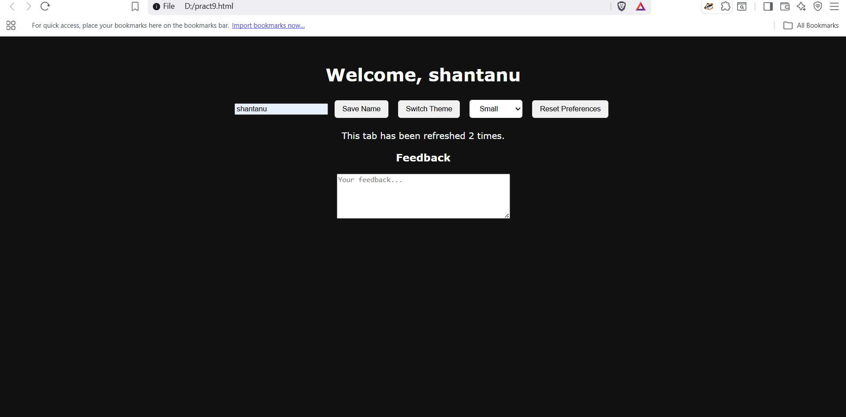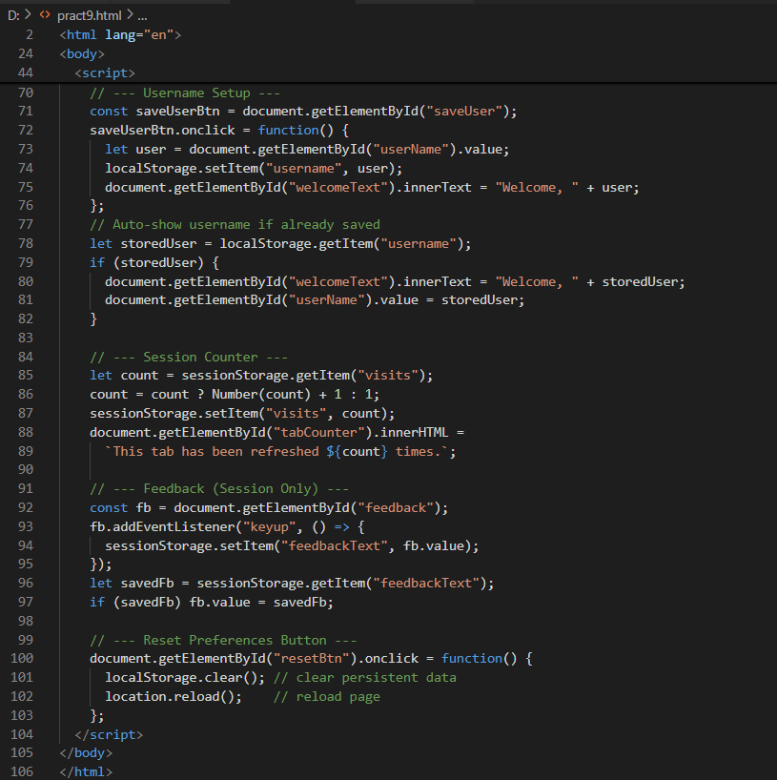<!DOCTYPE html>
<html lang="en">
<head>
<meta charset="UTF-8">
<title>Personal Dashboard</title>
<style>
body {
font-family: Verdana, sans-serif;
transition: all 0.4s ease;
text-align: center;
padding: 20px;
}
.dark { background-color: #121212; color: white; }
.light { background-color: #ffffff; color: black; }
#controls button, select {
margin: 6px;
padding: 8px 14px;
border: none;
border-radius: 5px;
cursor: pointer;
}
</style>
</head>
<body>
<h1 id="welcomeText">Welcome!</h1>

<div id="controls">
<input type="text" id="userName" placeholder="Enter your name">
<button id="saveUser">Save Name</button>
<button id="themeBtn">Switch Theme</button>
<select id="fontChooser">
<option value="small">Small</option>
<option value="medium">Medium</option>
<option value="large">Large</option>
</select>
<button id="resetBtn">Reset Preferences</button>
</div>

<p id="tabCounter"></p>

<h3>Feedback</h3>
<textarea id="feedback" rows="5" cols="40" placeholder="Your feedback..."></textarea>

<script>
// --- Theme Setup ---
let themeNow = localStorage.getItem("themeMode");
if (!themeNow) themeNow = "light"; // Default theme = light
document.body.classList.add(themeNow);

document.getElementById("themeBtn").onclick = function() {
let newTheme = document.body.classList.contains("light") ? "dark" : "light";
document.body.classList.remove("light", "dark");
document.body.classList.add(newTheme);
localStorage.setItem("themeMode", newTheme);
};

// --- Font Size Setup ---
const fSelect = document.getElementById("fontChooser");
fSelect.onchange = function() {
let f = fSelect.value;
document.body.style.fontSize = f;
localStorage.setItem("fontSizePref", f);
};
let storedFont = localStorage.getItem("fontSizePref");
if (storedFont) {
document.body.style.fontSize = storedFont;
fSelect.value = storedFont;
}

// --- Username Setup ---
const saveUserBtn = document.getElementById("saveUser");
saveUserBtn.onclick = function() {
let user = document.getElementById("userName").value;
localStorage.setItem("username", user);
document.getElementById("welcomeText").innerText = "Welcome, " + user;
};
// Auto-show username if already saved
let storedUser = localStorage.getItem("username");
if (storedUser) {
document.getElementById("welcomeText").innerText = "Welcome, " + storedUser;
document.getElementById("userName").value = storedUser;
}

// --- Session Counter ---
let count = sessionStorage.getItem("visits");
count = count ? Number(count) + 1 : 1;
sessionStorage.setItem("visits", count);
document.getElementById("tabCounter").innerHTML =
`This tab has been refreshed ${count} times.`;

// --- Feedback (Session Only) ---
const fb = document.getElementById("feedback");
fb.addEventListener("keyup", () => {
sessionStorage.setItem("feedbackText", fb.value);
});
let savedFb = sessionStorage.getItem("feedbackText");
if (savedFb) fb.value = savedFb;

// --- Reset Preferences Button ---
document.getElementById("resetBtn").onclick = function() {
localStorage.clear(); // clear persistent data
location.reload(); // reload page
};
</script>
</body>
</html>

